

Singing Workshop:

Raise Our Voices!

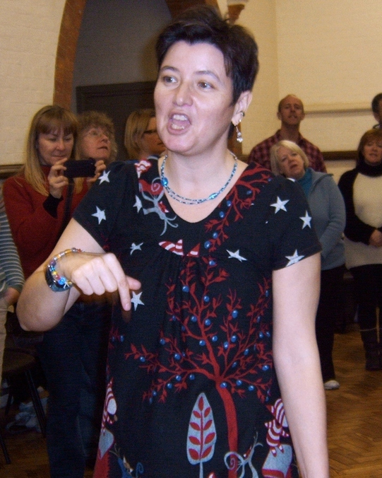

### with Becca Flintham

**Saturday 20th October,**

**10.30am – 4.00pm**

Treat yourself to a day of harmony singing:  
great songs to nurture our souls and lift our spirits!

Complete beginners and experienced singers equally welcome, no music-reading ability needed – all songs will be taught by ear. An uplifting and fun day’s singing open to all.

*Becca Flintham is a Natural Voice practitioner, singing teacher,  
performer and community choir leader*

**Cost £25 / £20 concessions**

# Venue: The Sutton Hall, Church Road, Stockcross, Newbury RG20 8LN.

Registration from 10.00am. Refreshments provided, please bring lunch to share.

## **To book places - Email: singwithbecca@gmail.com**

## **Telephone: 07717 846814**

For more information about my singing and other work,  
please visit my website at **www.rowanleaf.co.uk**